**Mr. Greevy’s Science Class Information Sheet 7th Grade Science**

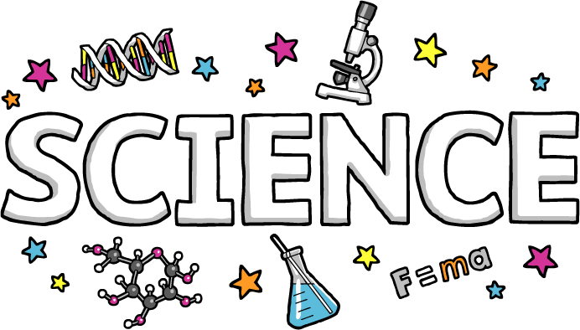

Please bring this paper home and read it together with your parent/guardian!

Then you may keep this copy.

**Materials for Class:**

Bound composition notebook (for science only)

Folder

Pen/pencil

Colored pencils

**Homework and Classwork:**

Students are expected to complete all homework and unfinished class assignments. It is the student’s responsibility to turn in all work on time. Homework turned in one day late will be counted as ½ credit, after that it will not be accepted. (Illness/extended absences from school can be discussed with Mr. Greevy on an individual basis). Homework is expected to be done neatly, completely, and on time. It is not expected that each individual answer to be correct, effort is the most important thing.

**Testing:** Students will be tested at the end of each chapter and unit. All test will be announced. Quizzes will be almost every week. Quizzes occasionally may be unannounced.

**Conduct:** Students will be expected to adhere to the Cornwall Central Middle School code of conduct at all times.

**Student Progress:** Student report card grades are based on the following.

30% Quizzes, 30% Tests, 20% Homework, 20% Classwork/participation in class

If students or parents ever have any questions about our class at any time please ask!

I am looking forward to an enjoyable and productive year. *–Mr. Greevy*

Please contact me any time at mgreevy@cornwallschools.com